

Task Manager Project Report

Mohammed Alluqman – 202210391

Faisal Alsubaie – 202110115

Faisal Salem – 202110170

Suliman Alotibe – 202210211

Ali Attyah – 202110581

CIT216 / Web Authoring and Design II

Dr. Hassan Al kaf

December 11, 2024

**Table of Contents**

**Introduction:** 3

**Project Details:** 3

**Screenshots with Descriptions:** 5

**Conclusion:** 7

# **Introduction:**

The Task Manager is a web-based application designed to help users efficiently organize and manage their tasks. Users can create, view, edit, and delete tasks, set priorities, and track deadlines. The project uses C#, ASP.NET, and SQL Server to deliver a user-friendly interface. By separating active and completed tasks, it aims to enhance productivity and keep users on schedule.

# **Project Details:**

**a) Project Idea and Why It Was Selected**

The idea of the Task Manager was conceived to address common productivity challenges. Many people struggle with tracking and organizing their tasks, leading to missed deadlines and decreased efficiency. This application was chosen to provide a simple yet effective solution for managing daily tasks.

**b) In-Depth Explanation**

The Task Manager offers the following features:

* Task Creation, Editing, and Deletion: Users can add new tasks, update existing ones, or delete completed tasks.
* Task Categorization: Tasks are categorized as active or completed.
* Task Prioritization and Deadlines: Users can assign priorities and deadlines to tasks for better management.
* Dashboard View: A clean layout displays active tasks and completed tasks in separate tabs.
* Calendar Integration: A calendar helps users visualize and track deadlines.
* Technologies Used: The project is developed using C#, ASP.NET, and SQL Server, ensuring robust backend support and a seamless user experience.

**c) Main Contribution**

The main contribution of the Task Manager project lies in its intuitive UI/UX and efficient task management capabilities. including the web interface, backend database integration, and task management logic. I ensured the design is simple, modern, and user friendly.

**d) Solved Problems**

The project resolved several challenges, including:

* Ensuring valid data input for registration and login was challenging. I solved it using client-side and server-side validation.
* Linking the forms with the database required proper connection strings and queries, which I configured successfully.
* Integrating a calendar system for better deadline visualization.
* Implementing smooth navigation between active and completed tasks.

**e) Unsolved Problems**

* Email notifications for upcoming deadlines.
* Automation for recurring tasks.

**f) Advantages and Disadvantages**

**Advantages**:

* Easy task organization.
* User-friendly interface.
* Efficient task filtering and status updates.

**Disadvantages:**

* Rely heavily on manual input from users.
* Lack of reminders/notifications.
* Limited task visualization (no graphs or calendars yet).

**g) Suggested Future Work**

Future enhancements could include:

* Email and push notifications for task reminders.
* Adding support for recurring tasks.
* Implementing task sharing for collaborative projects.

# **Screenshots with Descriptions:**

1. **Landing Page**

This page welcomes users to the Task Manager application. It explains the app’s purpose and provides simple navigation buttons for "Register" and "Login".

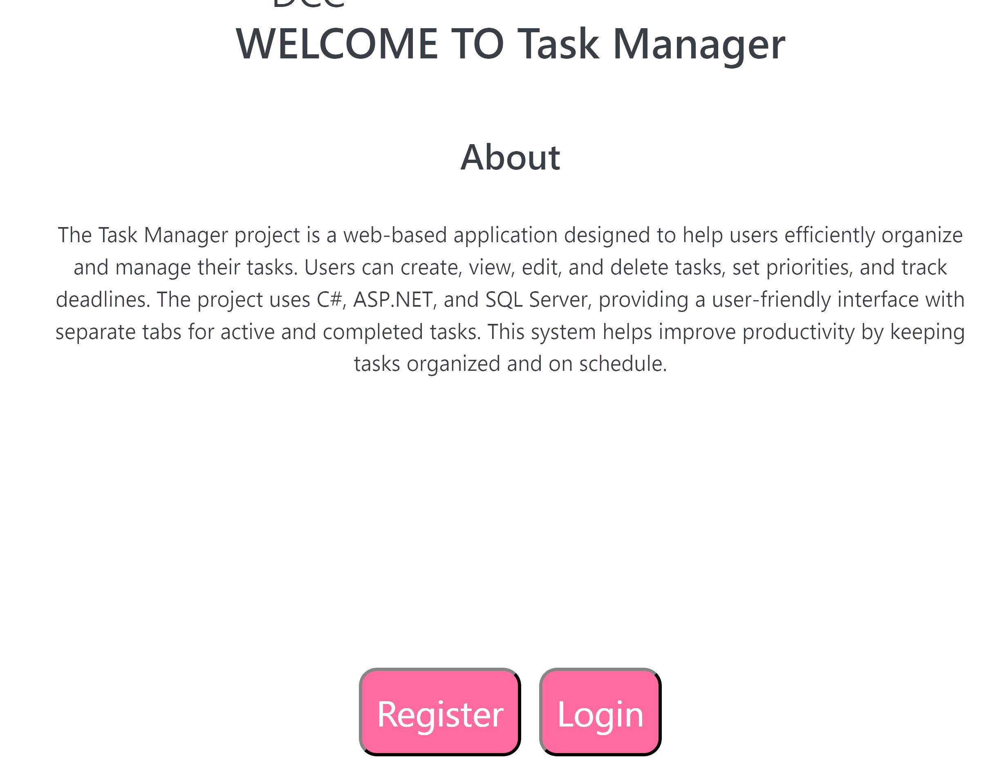

1. **Registration Page and Login Page:**

Users can register by entering details such as username, email, password, and personal information. The login page provides secure access with a "Trust This Device" option.

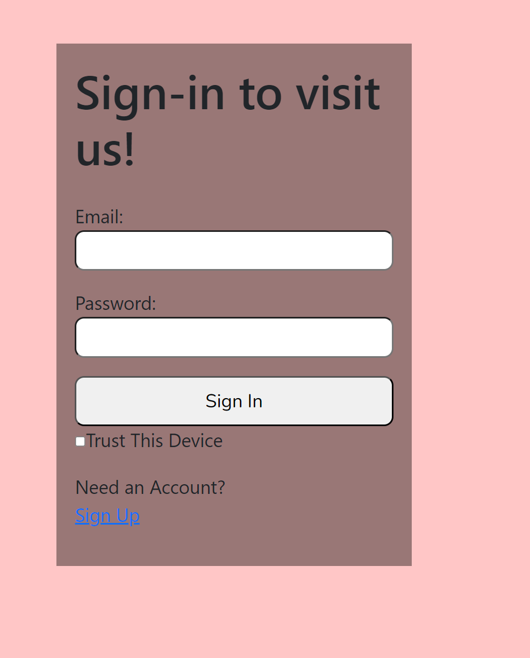

1. **Task Dashboard**

The main dashboard allows users to create new tasks, view active tasks, and manage completed tasks. Personalized messages and advice enhance the user’s experience.

1. **Task Details**

Active tasks can be viewed with their priority levels and due dates. Tasks can be marked as complete or removed easily from the dashboard.

1. **Completed Tasks**

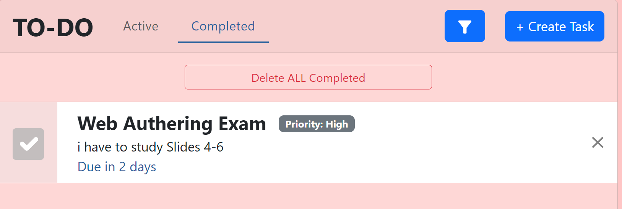

The completed tasks section allows users to review tasks they have finished. Users can choose to delete all completed tasks for better organization.

# **Conclusion:**

In conclusion, the Task Manager project helps users organize and manage their tasks easily. It provides features like adding, editing, and completing tasks while keeping everything organized. This system improves productivity and can be enhanced with more features in the future.